Executive Summary
As of Week 11, rIXD has processed 7.62% (Appendix A) of its retail volume by unit as Each Receive YTD. In Week 11, rIXD processed 6.78% (Appendix B) of its retail volume by unit as Each Receive – indicating significant improvement on the Each Receive Reduction front.

The strategy for Each Receive Reduction has involved targeting lifts several KPIs that are inversely related to Each Receive volume. At the forefront of these KPIs were EPP Coverage and LP Scan Compliance. EPP Coverage measures the percentage of pallets that go through the IMTP process and maintain trailer provenance. LP Scan Compliance measures the percentage of LP Pallet Labels scanned to paX via IMTP weighted by number of units attributed to each label. While both metrics are related to LP volume generation, there are avenues through which Each Receive volume can be created while still being compliant on both of the above.

In previous state, the rIXD network has had to rely on input metrics to measure sites effectiveness in Each Receive Reduction (or increased LP volume) because regional differences made it impossible to hold sites accountable to Each Receive outputs. However, it is possible to normalize by vendor, measuring each site by its actual versus expected retail Each Receive units according to the vendors it services.

EPP Coverage
In December 2024, rIXD performed at 76.76% for EPP Coverage. The network saw an increase in January to 79.24%, and a very sharp increase above the 90% goal to 92.33% in February with the successful rollout of Unload to paX. Sites stayed consistent and landed at 92.67% in March (Appendix C).

Currently, EPP Coverage is still a focus in RTB, but the expectation is that any sites not performing at 90% be given action plans to exceed threshold, with only a few outliers not hitting target.

EPP Coverage has one significant gap in the grand scheme of ER Reduction, which is that the denominator for this metric only includes pallets that were put through the IMTP process. If the IMTP process is completely bypassed (which could generate Each Receive volume), this metric will not flag that as a defect.

LP Scan Compliance
From WK1 to WK 13, rIXD improved in LP Scan Compliance from 67.7% (Appendix D) to 75.7% (Appendix E). A limiter to the growth of this metric is that a significant percentage of defects for this metric are difficult or impossible to narrow down to an associate to provide coaching. If the IMTP process is bypassed entirely, this metric will register a fail, but it is very difficult to attribute to an associate. Additionally, its can be difficult to determine which defects can be attributed to vendors versus Operations.

There is still a lot of momentum in the LP Scan Compliance space to improve this metric, and it certainly is more restrictive than EPP Coverage. All of the above factors aside, a major gap with LP Scan Compliance as it relates to Each Receive Reduction is that a passing scan can still result in Each Receive Volume being generated. Especially when sites are using IMTP toggles (SAP/MAP) to try to drive the freight in one direction or the other in order to hit their PID Carton and Combined Carton goals with available freight, there is a high chance that Each Receive Volume will be created from SAP, when Pallet Receive would be the best FPP from a Cost and Each Receive Reduction standpoint.

Mix-Adjusted Site Performance
To address the gaps, it is possible to consider each site’s performance in ER Reduction relative to their “vendor mix”. Below are the details of this analysis process.

First, we can give each vendor a baseline ER % (Appendix F). For brevity, the entire file will be included separately from this report. Then we can generate a breakdown of vendor % by site (Appendix G). From there, we can compile this data together to form a projected Each Receive % versus actual Each Receive % Analysis per site. This information can be used as a starting point for conversations around the habits that are resulting in Each Receive creation.

Appendix
Appendix A: YTD rIXD Retail FPP
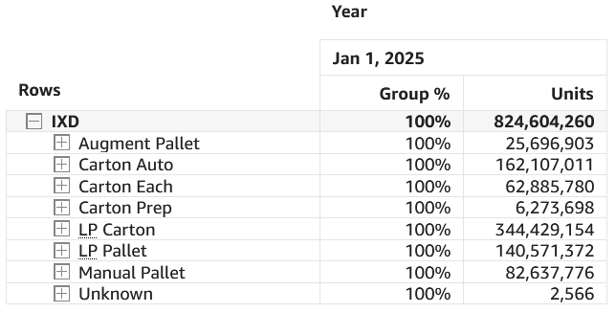
Appendix B: Week 8 to 11 rIXD Retail FPP
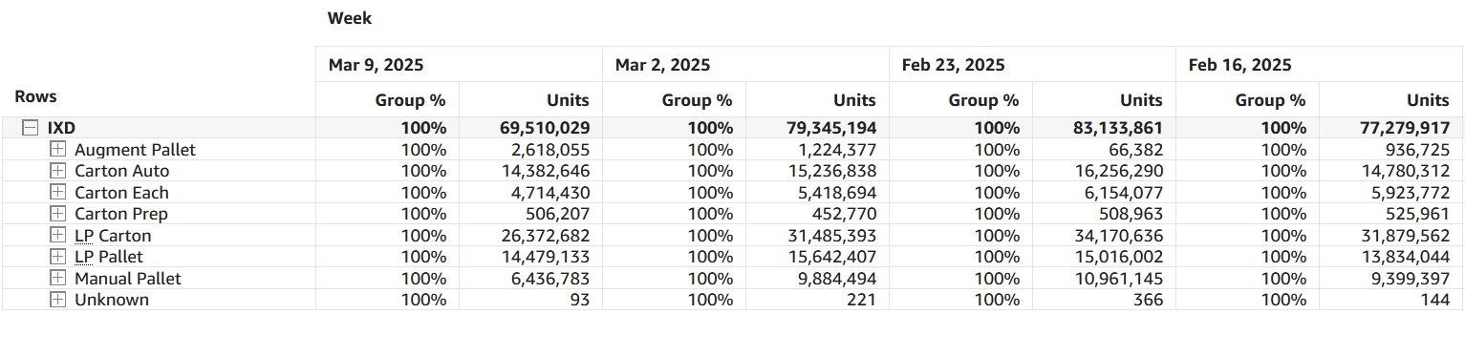

Appendix C: rIXD Monthly EPP Metrics Sep. 24 to Mar. 25
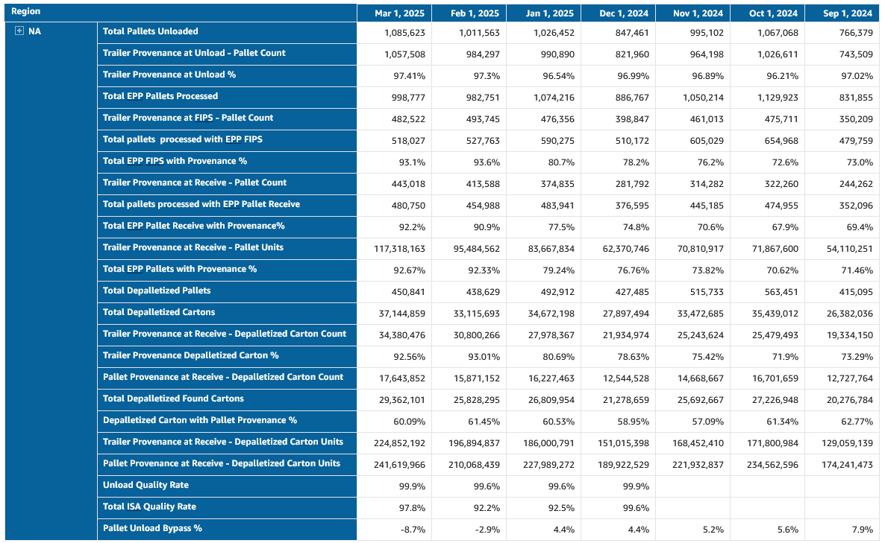

Appendix D: rIXD Week 1 Retail LP Scan Compliance
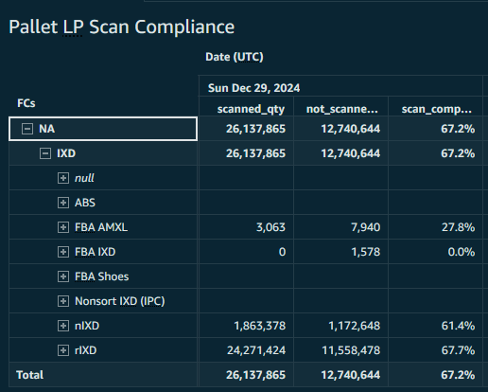
Appendix E: rIXD Week 13 Retail LP Scan Compliance
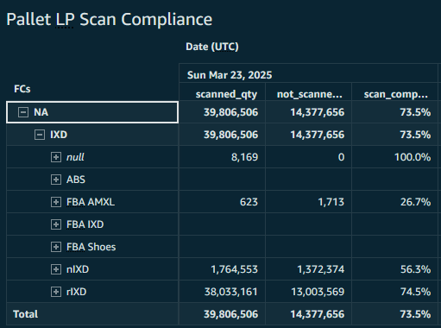

Appendix F: Vendor Each Receive %
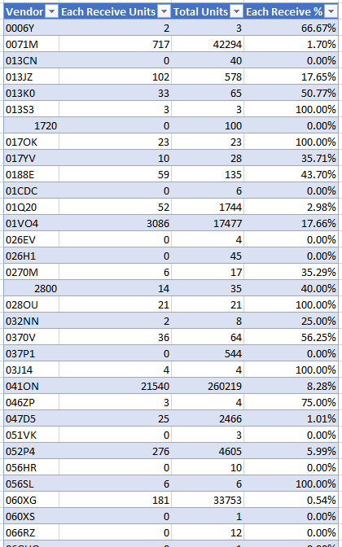

Appendix G: Vendor Mix % By Site
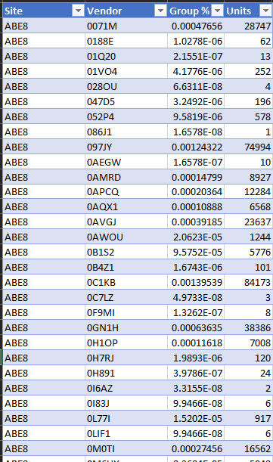

Appendix F: Projected Versus Actual ER % By Site 2025 YTD
